**Identified code smells**

* Rodrigo Lopes 58013

Code smell 1 - Long Method

* **exact location**: /Users/rodrigo/Desktop/ganttproject-master/ganttproject/src/main/java/net/sourceforge/ganttproject/document/DocumentCreator.java
* **An explanation for identifying this code smell**: The method is too long and hard to understand.
* **A refactoring proposal:** Split the long method into smaller methods.
* **Illustrating code snippet:**

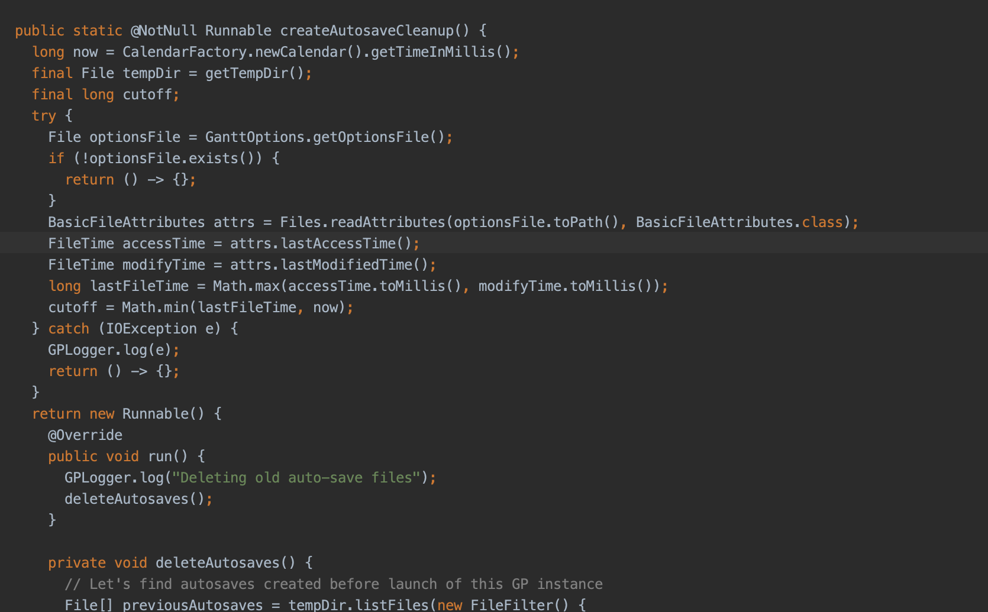

Code smell 2 - Clarification Comment

* **exact location**: /Users/rodrigo/Desktop/ganttproject-master/ganttproject/src/main/java/net/sourceforge/ganttproject/client/RssFeedChecker.java
* **An explanation for identifying this code smell**: To many comments on the method
* **A refactoring proposal:** Deleting the comments and leaving only the code
* **Illustrating code snippet:**

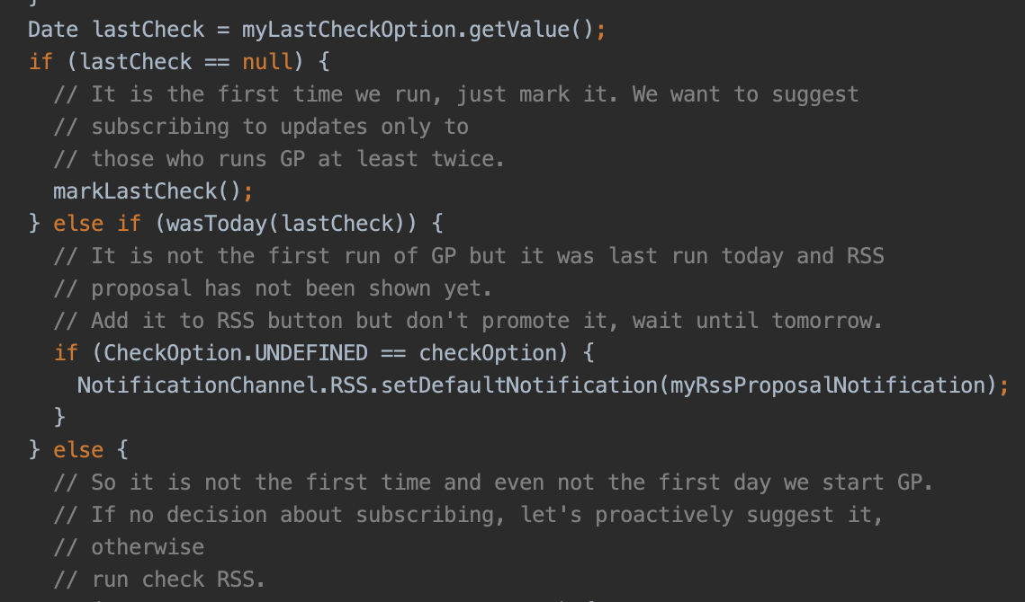

Code smell 3 - Dead code

* **exact location**: /Users/rodrigo/Desktop/ganttproject-master/ganttproject/src/main/java/net/sourceforge/ganttproject/client/RssFeedChecker.java
* **An explanation for identifying this code smell**: The method createUpdateDialog doesn’t do anything
* **A refactoring proposal:** Deleting the method and the places where it is used
* **Illustrating code snippet:**

